Guidelines - Dashboard for SD Model Using Forio
- Install VENSIM PLE
- Link: Open the link to create the model: https://forio.com/epicenter
- Login/Signup: If you don’t have a Forio account, create an account using the Signup. Otherwise, login using your signed-up email address and password.
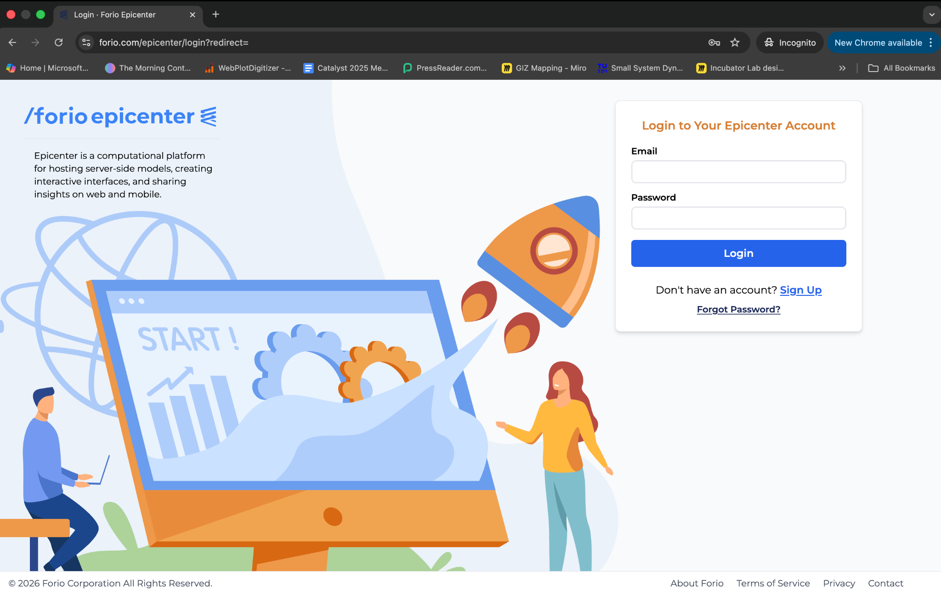

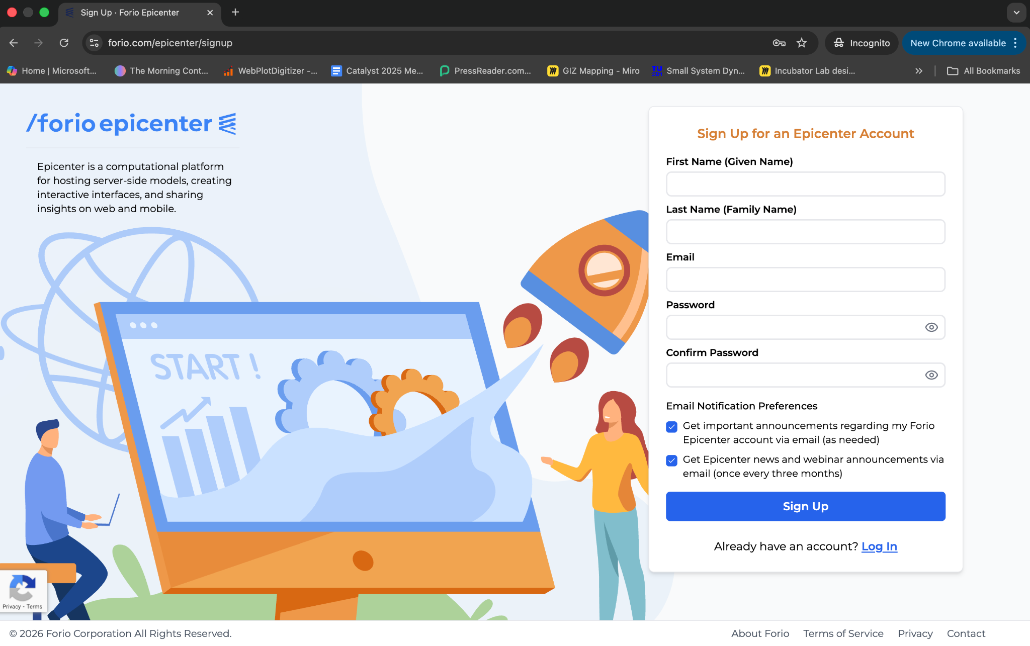

- Create Project: Click on the “Create Personal Project” button in the Personal Workspace Section

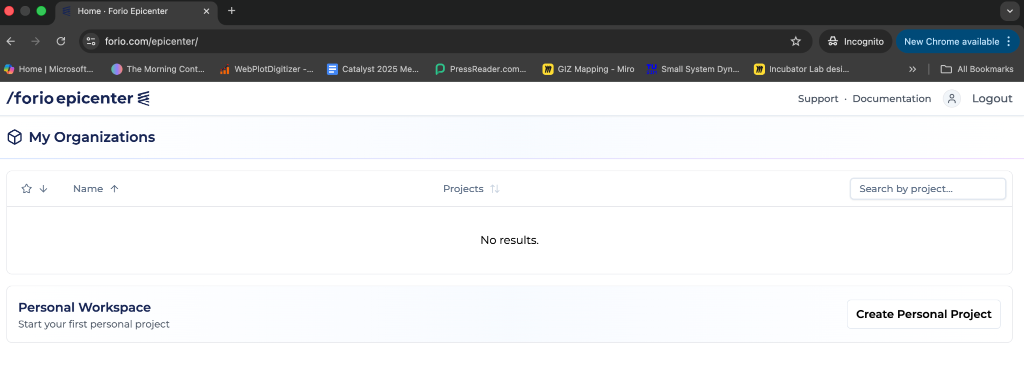

Fig: Personal Workspace
If you are using Forio for the first time, then you might be asked to create a “Personal Organisation ID”. It automatically fills the ID field with the same email name you used during signup. However, if you want to change it, you can customise it as per your needs. After setting the ID, click “Ok” and proceed.
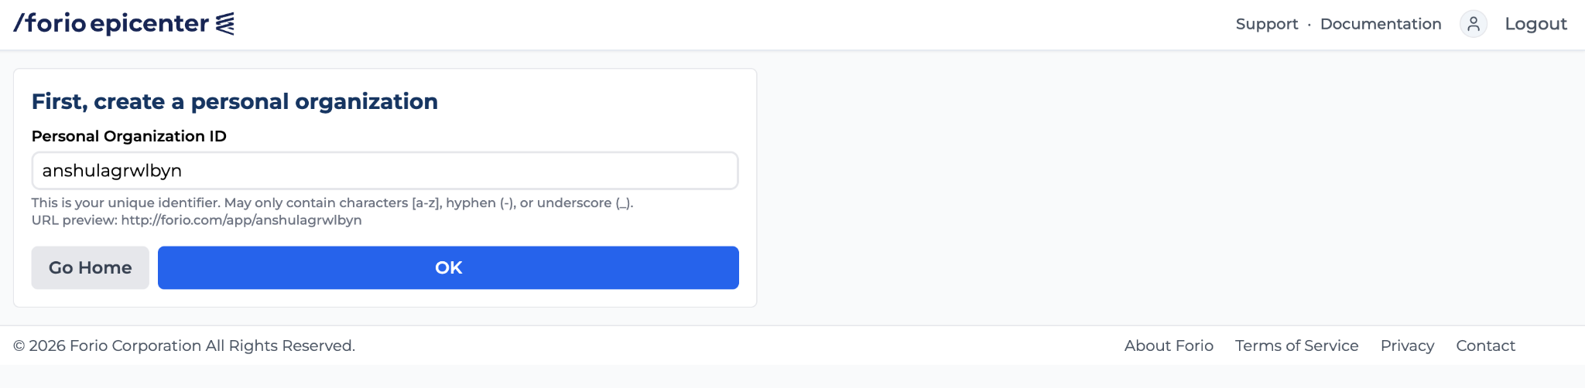

You will be directed to create a project page where you can name your project. The Project ID is automatically filled based on the project name; however, you can change it as needed. These fields can also be changed later.
In the project access field, you can choose whether to keep the project accessible to anyone or keep it private.
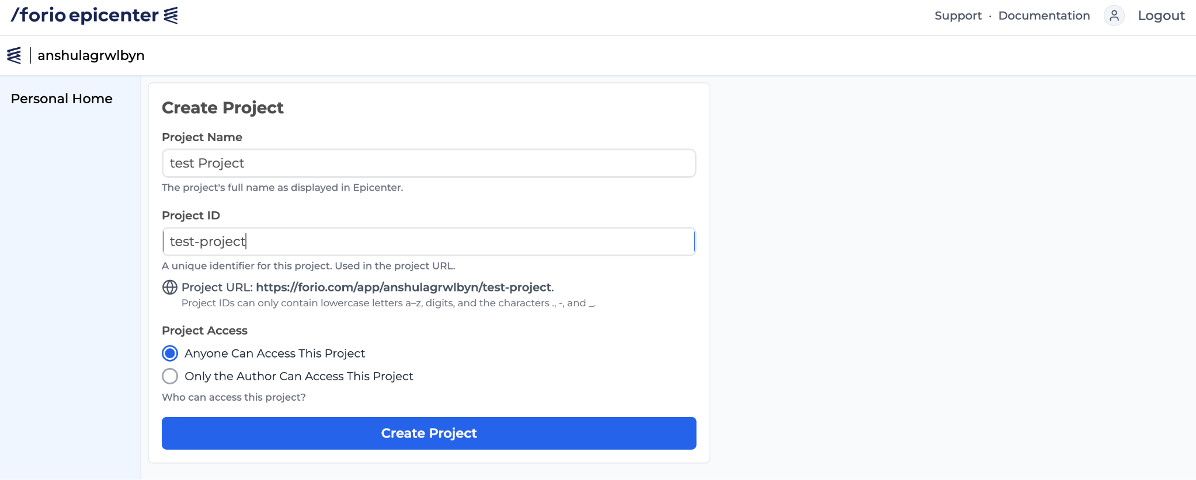

- Adding models and files to your project: After creating the project, you will be on the project homepage, where you have to click on “Project Files” in the left panel.
Once you are on the Project Files page, click “Upload File(s)”.

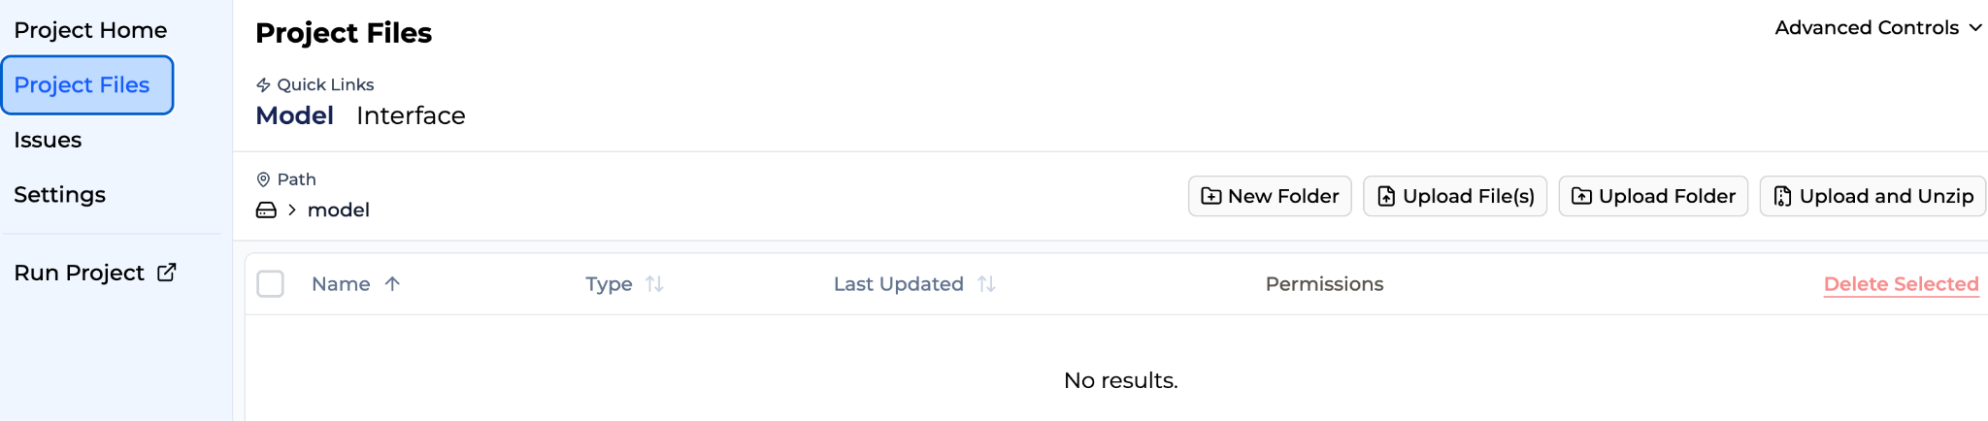

Please ensure you have saved the Vensim model file as .vmfx using Vensim's “Save As” option.
After clicking “Upload file(s)”, you will be asked to upload the model file. Navigate to the “.vmfx” version of your SD model and upload it.
You will find the model file as shown in the image below:
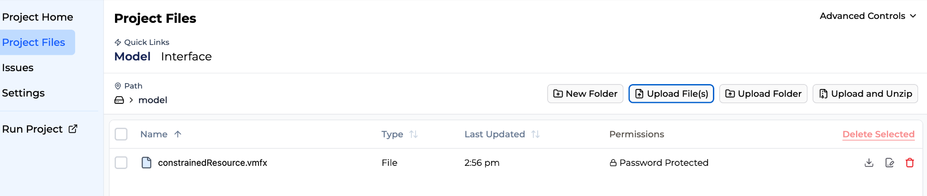

- Creating the dashboard interface:
Click on the “Interface” tab, right next to the Model tab.
In the “Interface” tab, click on the “Open Interface Builder” on the right-hand side. 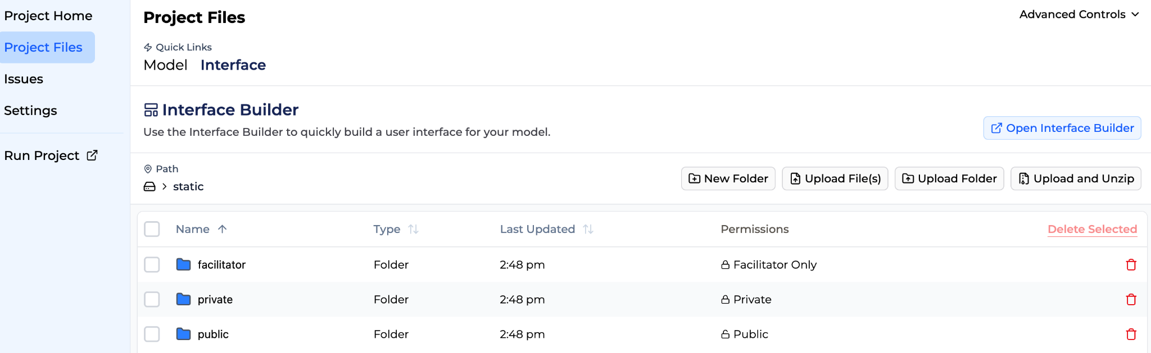

After clicking on the “Open Interface Builder”, you will be shown a screen like this:
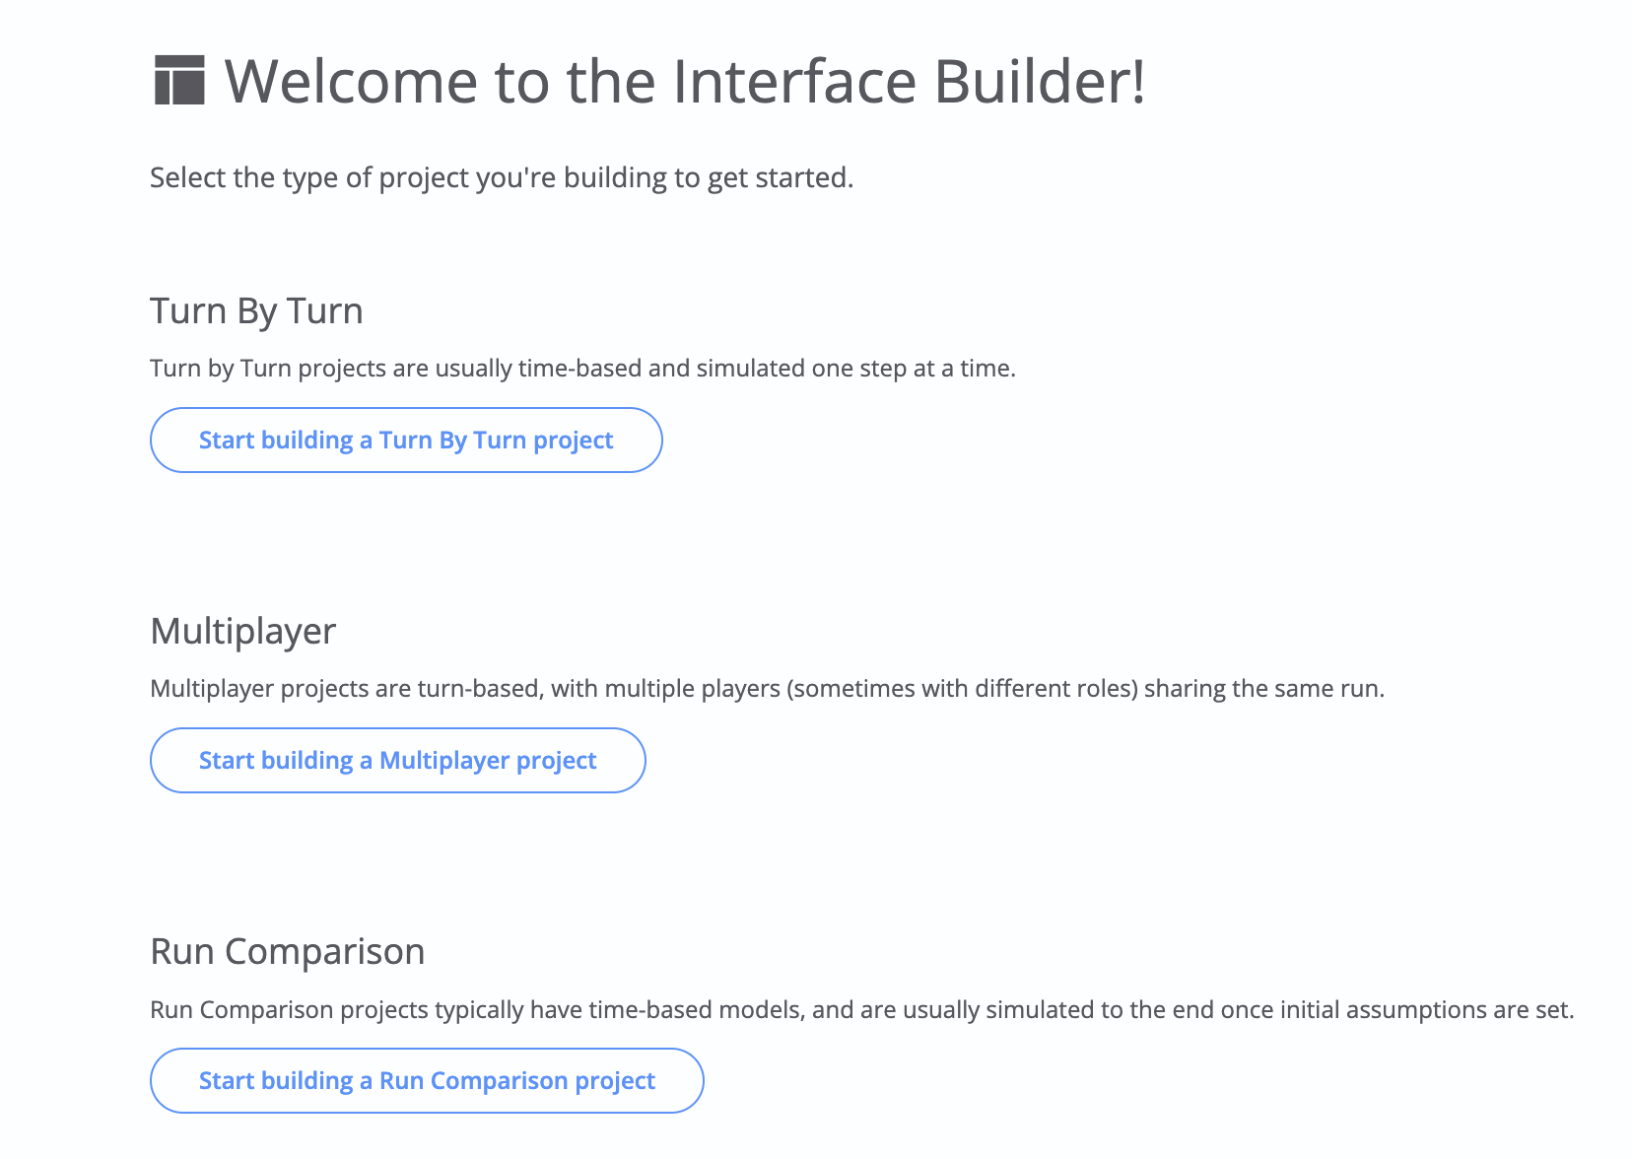

We will be using the Run Comparison dashboard type. Click on “Start building a Run Comparison project”. You will be redirected to a screen below:
The Forio template has prebuilt
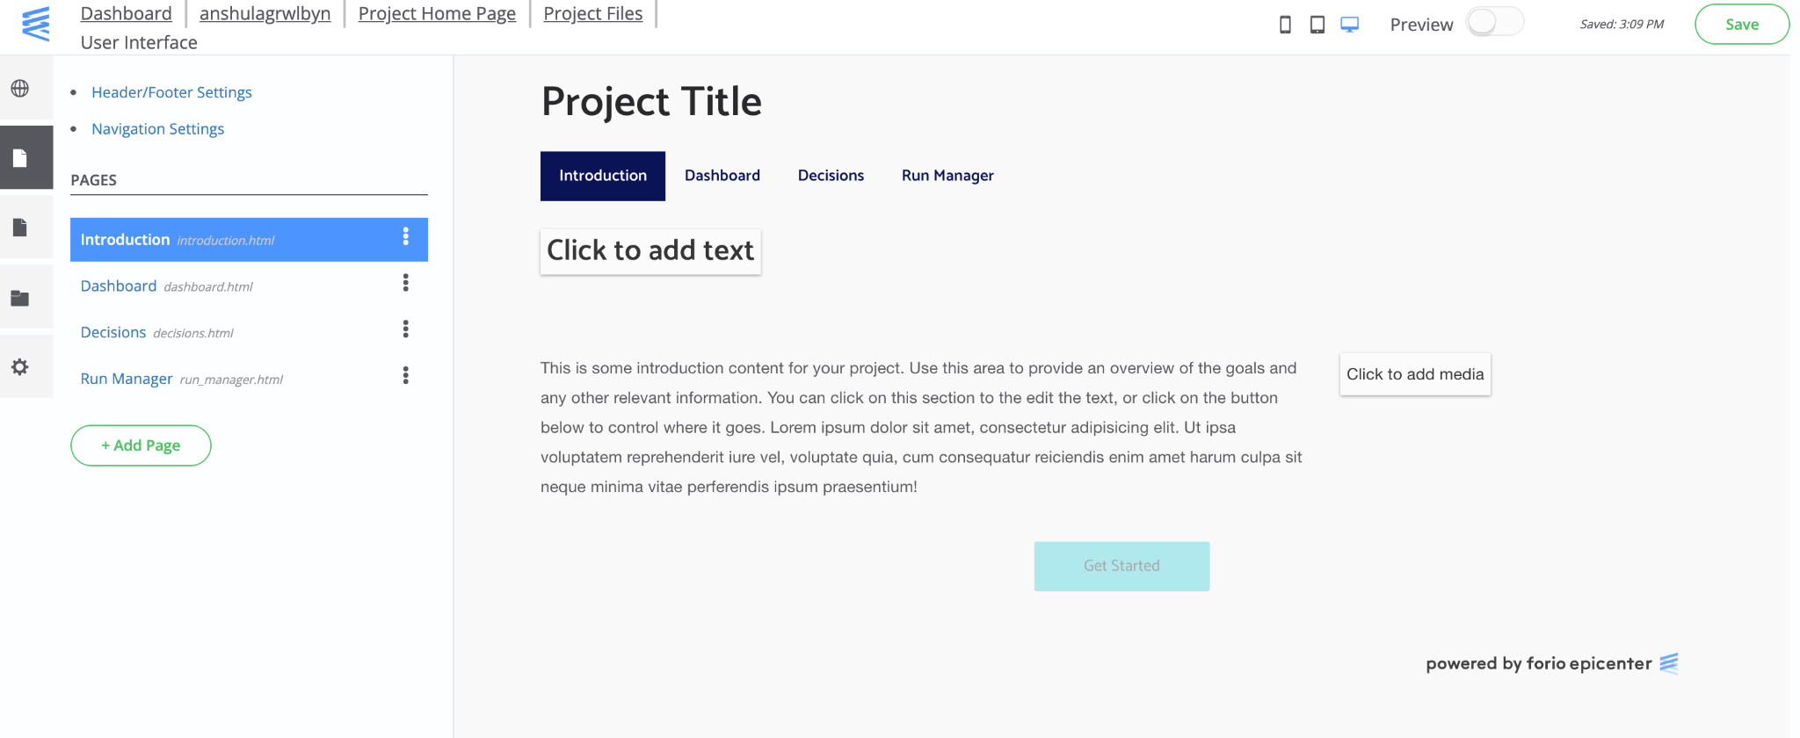

Accessing the Dashboard
- Project URL: This link can be shared with anyone who wants to use the dashboard. This link doesn’t give project edit access; it’s for using the dashboard.
- Run Project: Use this option to run the dashboard on your system. This opens the same link as in the “Project URL”
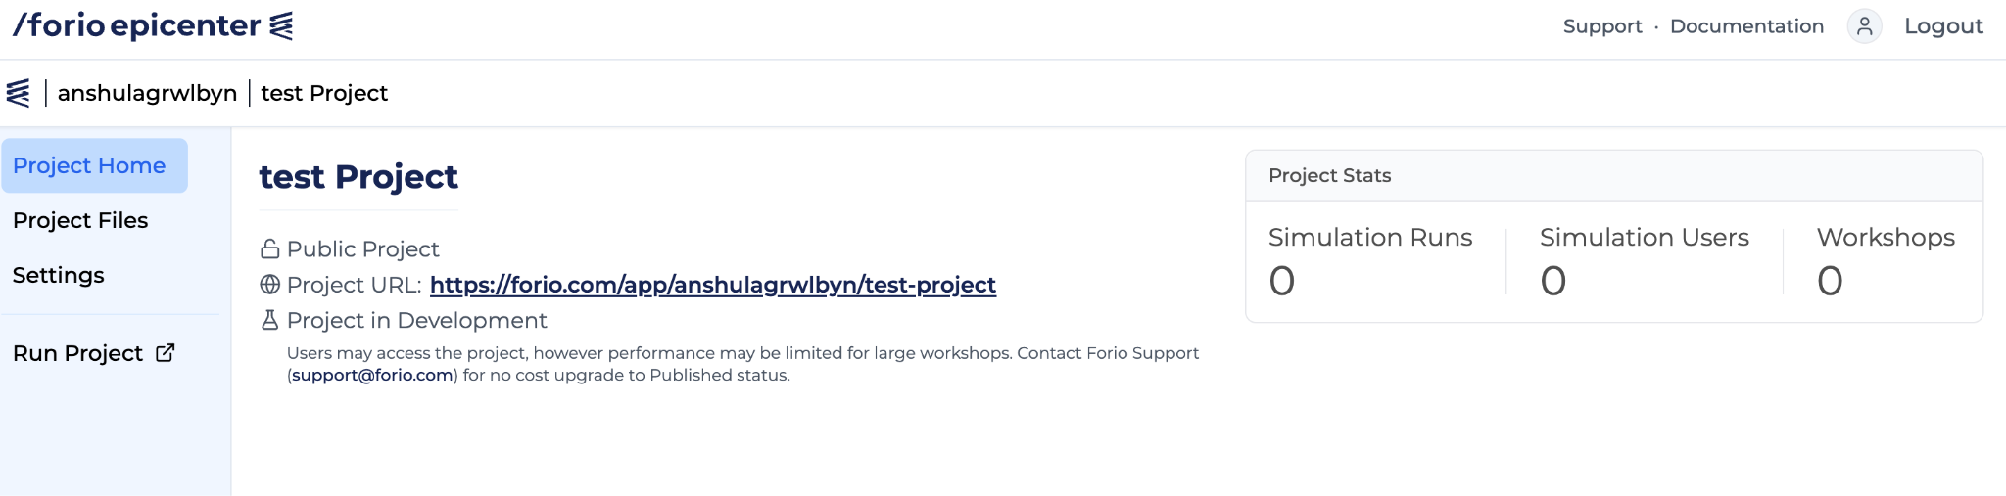

Note: Please ensure you have a project zip file from someone who has already created a dashboard, and that you want to replicate in your account. If you want to create your own dashboard from scratch using a Vensim model file, you will need a different instruction set, which is not covered in this guideline. Note that steps 1 through 4 remain applicable even when creating a dashboard from scratch.

